**Initial Proposal**

As a business owner I was creating and simple online selling solution for the computer sales and parts as part of a database design I have created a tables like org organization employees orders order items and products. Where I could set up app complete clean operational and simple solution to have the computers to be sell online. So the complete inventory of the orders and the products that have been provided in the system are to be tracked with that as simple and sophisticated solution so for this I’m using the different kinds of formalwear systems that could be either Python or PHP for the transport layer and we can I can use some different technologies for the middleware**.**

**Data Sources:**

**As a Business Owner I suggest where the complete data need to be addressed through the data model that we have provide to the application. For example if the inventory need to be updated to the solution we need to be addressed with the specific towards the business entities. The product entity we need to support the Json to upload the bulk information where as the if any user to the customer is to be added they need to added with the sophisticated way they need to enter the name, mobile and address by their own. So we can support (JSON,CSV And Text entries).**

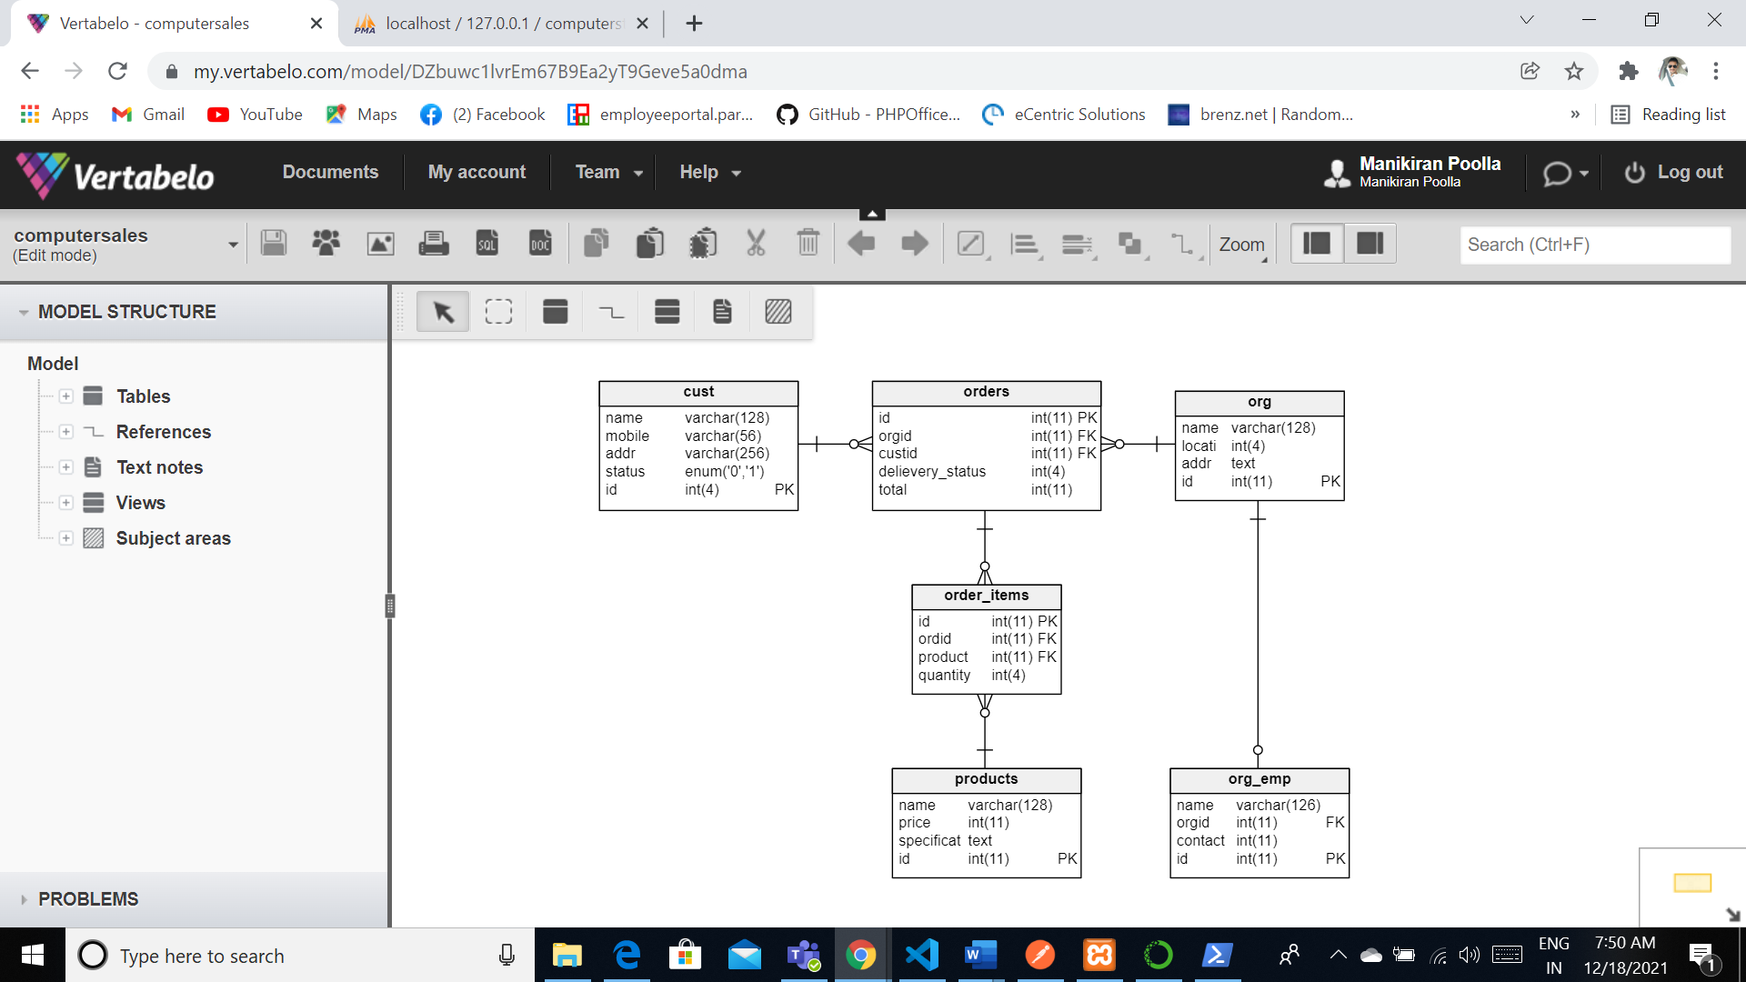

**Relational Database Design Process**

**For the relationship database I have used what blow to create ad sample database model data model that where it could be identified the clean and the sophisticated data model solution that it automatically. Please find the below screenshot that determines that where the complete solutions of the data elements thata were identified by the business owner**

**Data Definition Language Scripts**

**We use** Vertabello to generate the modeling scripts and other functions here is the basic model of the application



Here is the script generated by the Vertebello;

-- Created by Vertabelo (http://vertabelo.com)

-- Last modification date: 2021-12-18 02:11:37.462

-- tables

-- Table: cust

CREATE TABLE cust (

    name varchar(128) NOT NULL,

    mobile varchar(56) NOT NULL,

    addr varchar(256) NOT NULL,

    status enum('0','1') NOT NULL DEFAULT '0',

    id int(4) NOT NULL AUTO_INCREMENT,

    CONSTRAINT cust_pk PRIMARY KEY (id)

) ENGINE InnoDB CHARACTER SET utf8mb4;

-- Table: order_items

CREATE TABLE order_items (

    id int(11) NOT NULL,

    ordid int(11) NOT NULL,

    product int(11) NOT NULL,

    quantity int(4) NOT NULL,

    CONSTRAINT order_items_pk PRIMARY KEY (id)

) ENGINE InnoDB CHARACTER SET utf8mb4;

CREATE INDEX ordid ON order_items (ordid);

CREATE INDEX product ON order_items (product);

-- Table: orders

CREATE TABLE orders (

    id int(11) NOT NULL,

    orgid int(11) NOT NULL,

    custid int(11) NOT NULL,

    delievery_status int(4) NOT NULL,

    total int(11) NOT NULL,

    CONSTRAINT orders_pk PRIMARY KEY (id)

) ENGINE InnoDB CHARACTER SET utf8mb4;

CREATE INDEX orgid ON orders (orgid);

CREATE INDEX custid ON orders (custid);

CREATE INDEX delievery_status ON orders (delievery_status);

-- Table: org

CREATE TABLE org (

    name varchar(128) NOT NULL,

    location int(4) NOT NULL,

    addr text NOT NULL,

    id int(11) NOT NULL AUTO_INCREMENT,

    CONSTRAINT org_pk PRIMARY KEY (id)

) ENGINE InnoDB CHARACTER SET utf8mb4;

CREATE INDEX id ON org (id);

-- Table: org_emp

CREATE TABLE org_emp (

    name varchar(126) NOT NULL,

    orgid int(11) NOT NULL,

    contactnum int(11) NOT NULL,

    id int(11) NOT NULL AUTO_INCREMENT,

    UNIQUE INDEX orgid (orgid),

    CONSTRAINT org_emp_pk PRIMARY KEY (id)

) ENGINE InnoDB CHARACTER SET utf8mb4;

-- Table: products

CREATE TABLE products (

    name varchar(128) NOT NULL,

    price int(11) NOT NULL,

    specifications text NOT NULL,

    id int(11) NOT NULL AUTO_INCREMENT,

    CONSTRAINT products_pk PRIMARY KEY (id)

) ENGINE InnoDB CHARACTER SET utf8mb4;

-- foreign keys

-- Reference: order_items_ibfk_1 (table: order_items)

ALTER TABLE order_items ADD CONSTRAINT order_items_ibfk_1 FOREIGN KEY order_items_ibfk_1 (ordid)

    REFERENCES orders (id)

    ON DELETE CASCADE

    ON UPDATE CASCADE;

-- Reference: order_items_ibfk_2 (table: order_items)

ALTER TABLE order_items ADD CONSTRAINT order_items_ibfk_2 FOREIGN KEY order_items_ibfk_2 (product)

    REFERENCES products (id)

    ON DELETE CASCADE

    ON UPDATE CASCADE;

-- Reference: orders_ibfk_1 (table: orders)

ALTER TABLE orders ADD CONSTRAINT orders_ibfk_1 FOREIGN KEY orders_ibfk_1 (orgid)

    REFERENCES org (id)

    ON DELETE CASCADE

    ON UPDATE CASCADE;

-- Reference: orders_ibfk_2 (table: orders)

ALTER TABLE orders ADD CONSTRAINT orders_ibfk_2 FOREIGN KEY orders_ibfk_2 (custid)

    REFERENCES cust (id)

    ON DELETE CASCADE

    ON UPDATE CASCADE;

-- Reference: org_emp_ibfk_1 (table: org_emp)

ALTER TABLE org_emp ADD CONSTRAINT org_emp_ibfk_1 FOREIGN KEY org_emp_ibfk_1 (orgid)

    REFERENCES org (id)

    ON DELETE CASCADE

    ON UPDATE CASCADE;

-- End of file.

Data Dump to our local server: I’m using the maria db xampp stack so I’m importing the data

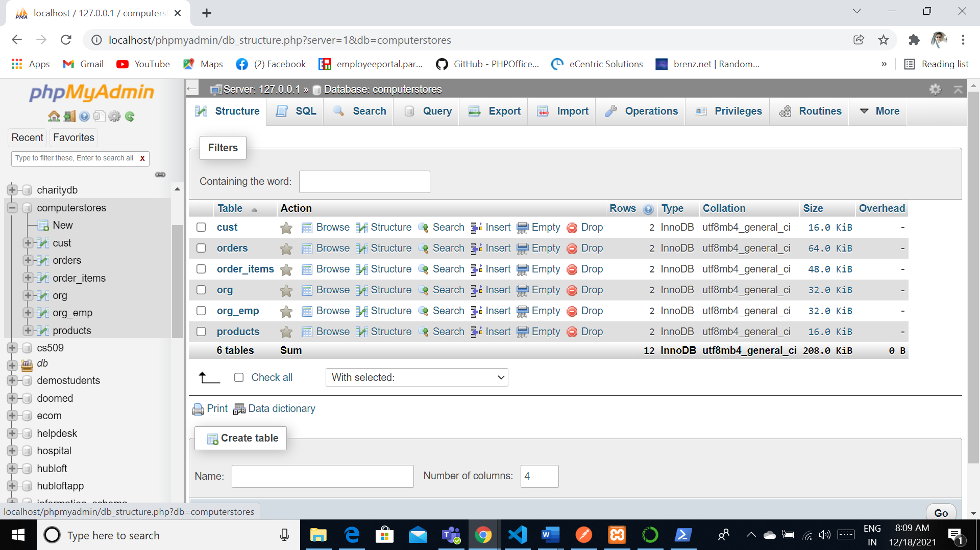

All the tables imported successfully

**Data Manipulation Language Scripts**

**Insert Statements**

[INSERT](http://localhost/phpmyadmin/url.php?url=https://dev.mysql.com/doc/refman/5.5/en/insert.html) INTO `cust` (`id`, `name`, `mobile`, `addr`, `status`) [VALUES](http://localhost/phpmyadmin/url.php?url=https://dev.mysql.com/doc/refman/5.5/en/miscellaneous-functions.html#function_values) (NULL, 'Doe', '7894561230', 'xyz place', '1'), (NULL, 'Kane', '4569871230', 'BEKKSIJKKKS789966', '1');

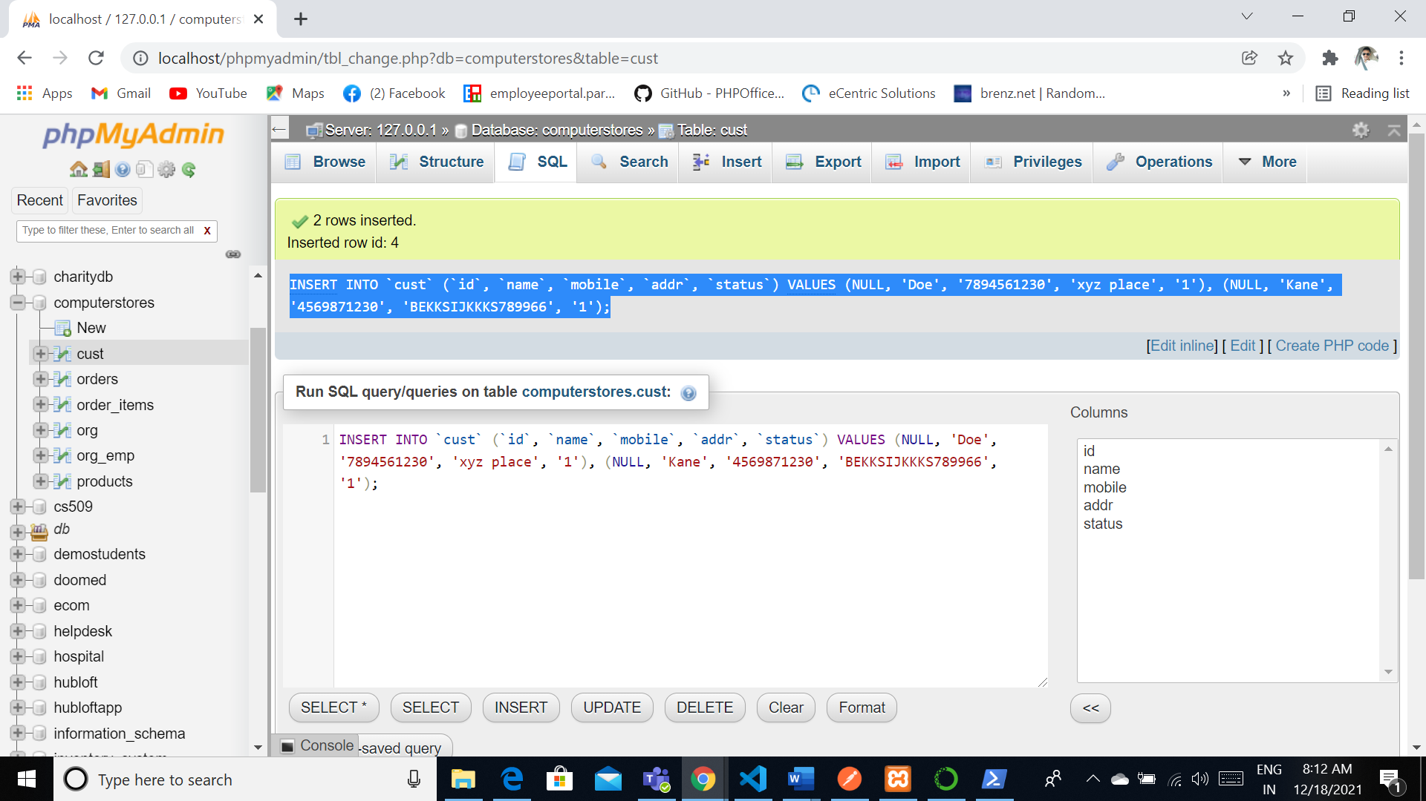

[INSERT](http://localhost/phpmyadmin/url.php?url=https://dev.mysql.com/doc/refman/5.5/en/insert.html) INTO `cust` (`id`, `name`, `mobile`, `addr`, `status`) [VALUES](http://localhost/phpmyadmin/url.php?url=https://dev.mysql.com/doc/refman/5.5/en/miscellaneous-functions.html#function_values) (NULL, 'JANE', '97463210', 'XYZ', '1');

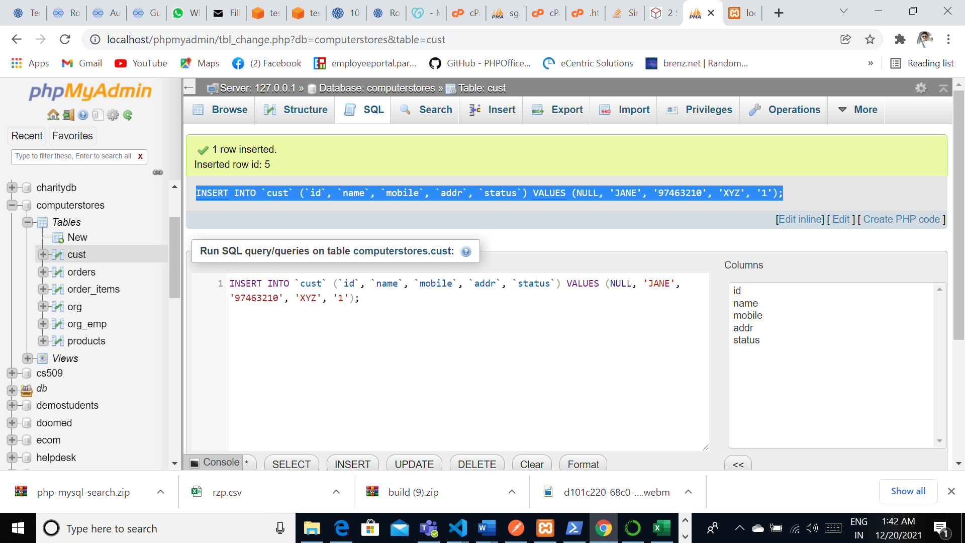

Update:

UPDATE `cust` SET `status` = '1' WHERE `cust`.`id` = 2;

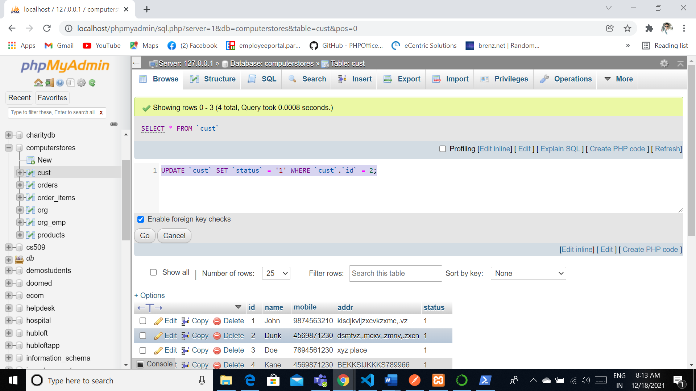

UPDATE `org` SET `name` = 'GOorg' WHERE `org`.`id` = 3;

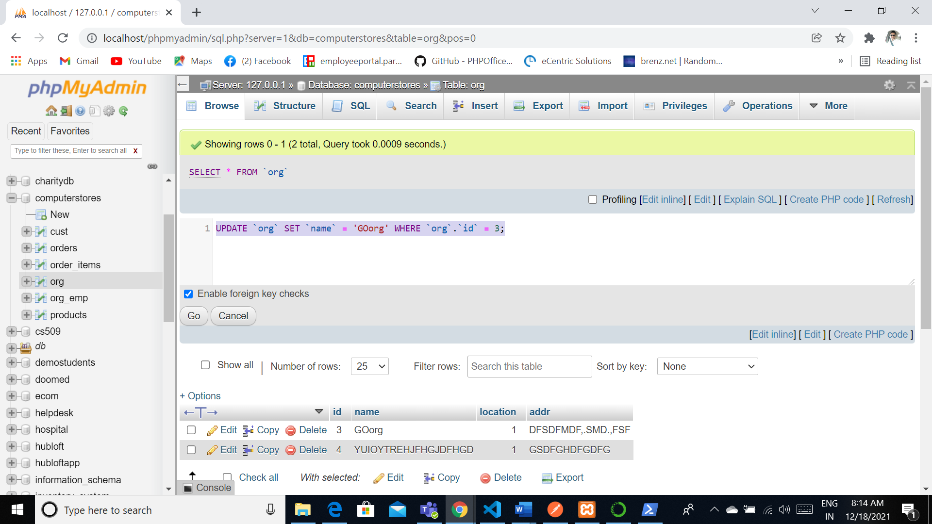

Delete:

DELETE FROM `cars` WHERE `cars`.`id` = 4

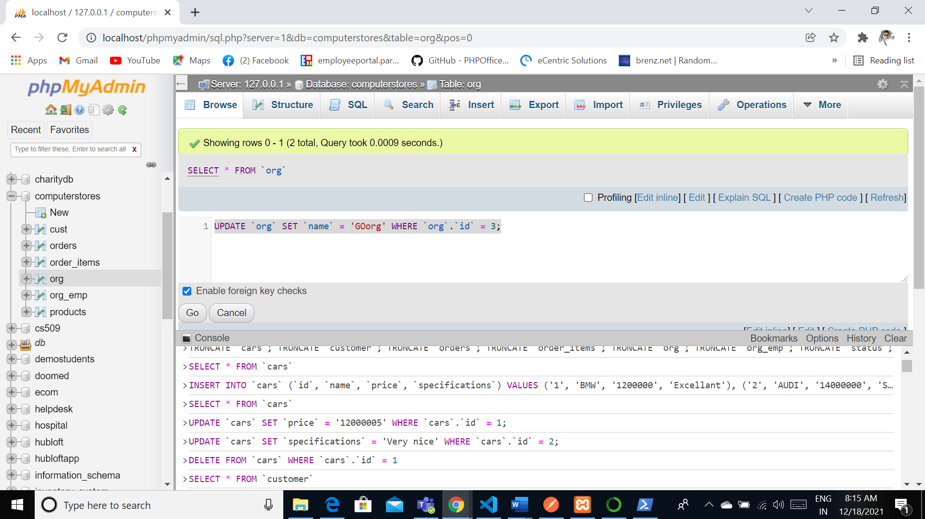

[SELECT](http://localhost/phpmyadmin/url.php?url=https://dev.mysql.com/doc/refman/5.5/en/select.html) * FROM `orders`

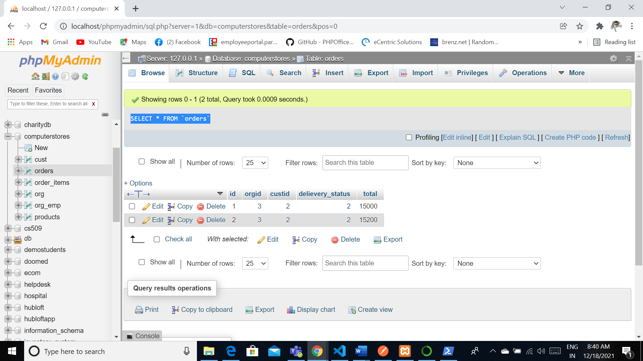

SELECT og.*,od.* from org og

INNER JOIN orders od on od.orgid=og.id

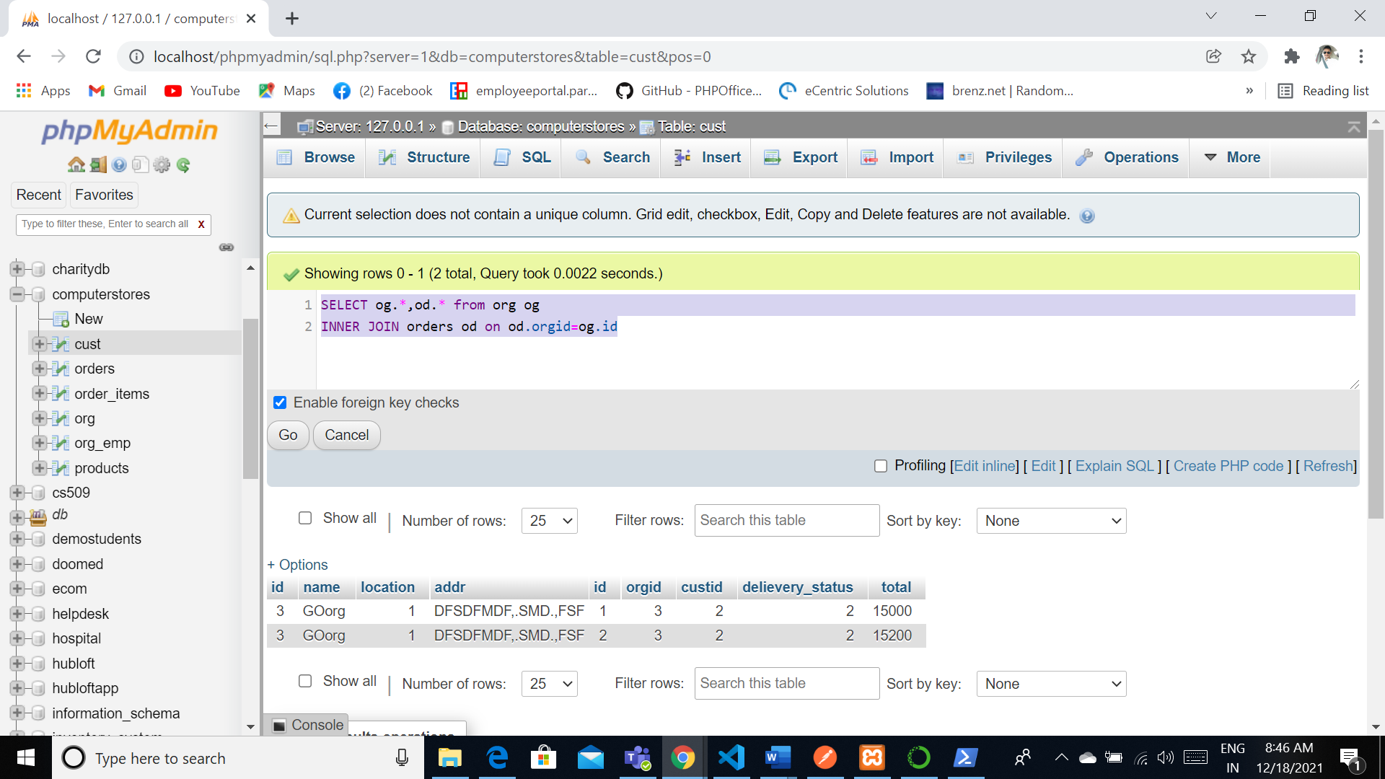

SELECT og.*,od.*,c.name from org og

INNER JOIN orders od on od.orgid=og.id

INNER JOIN cust c on c.id=od.custid

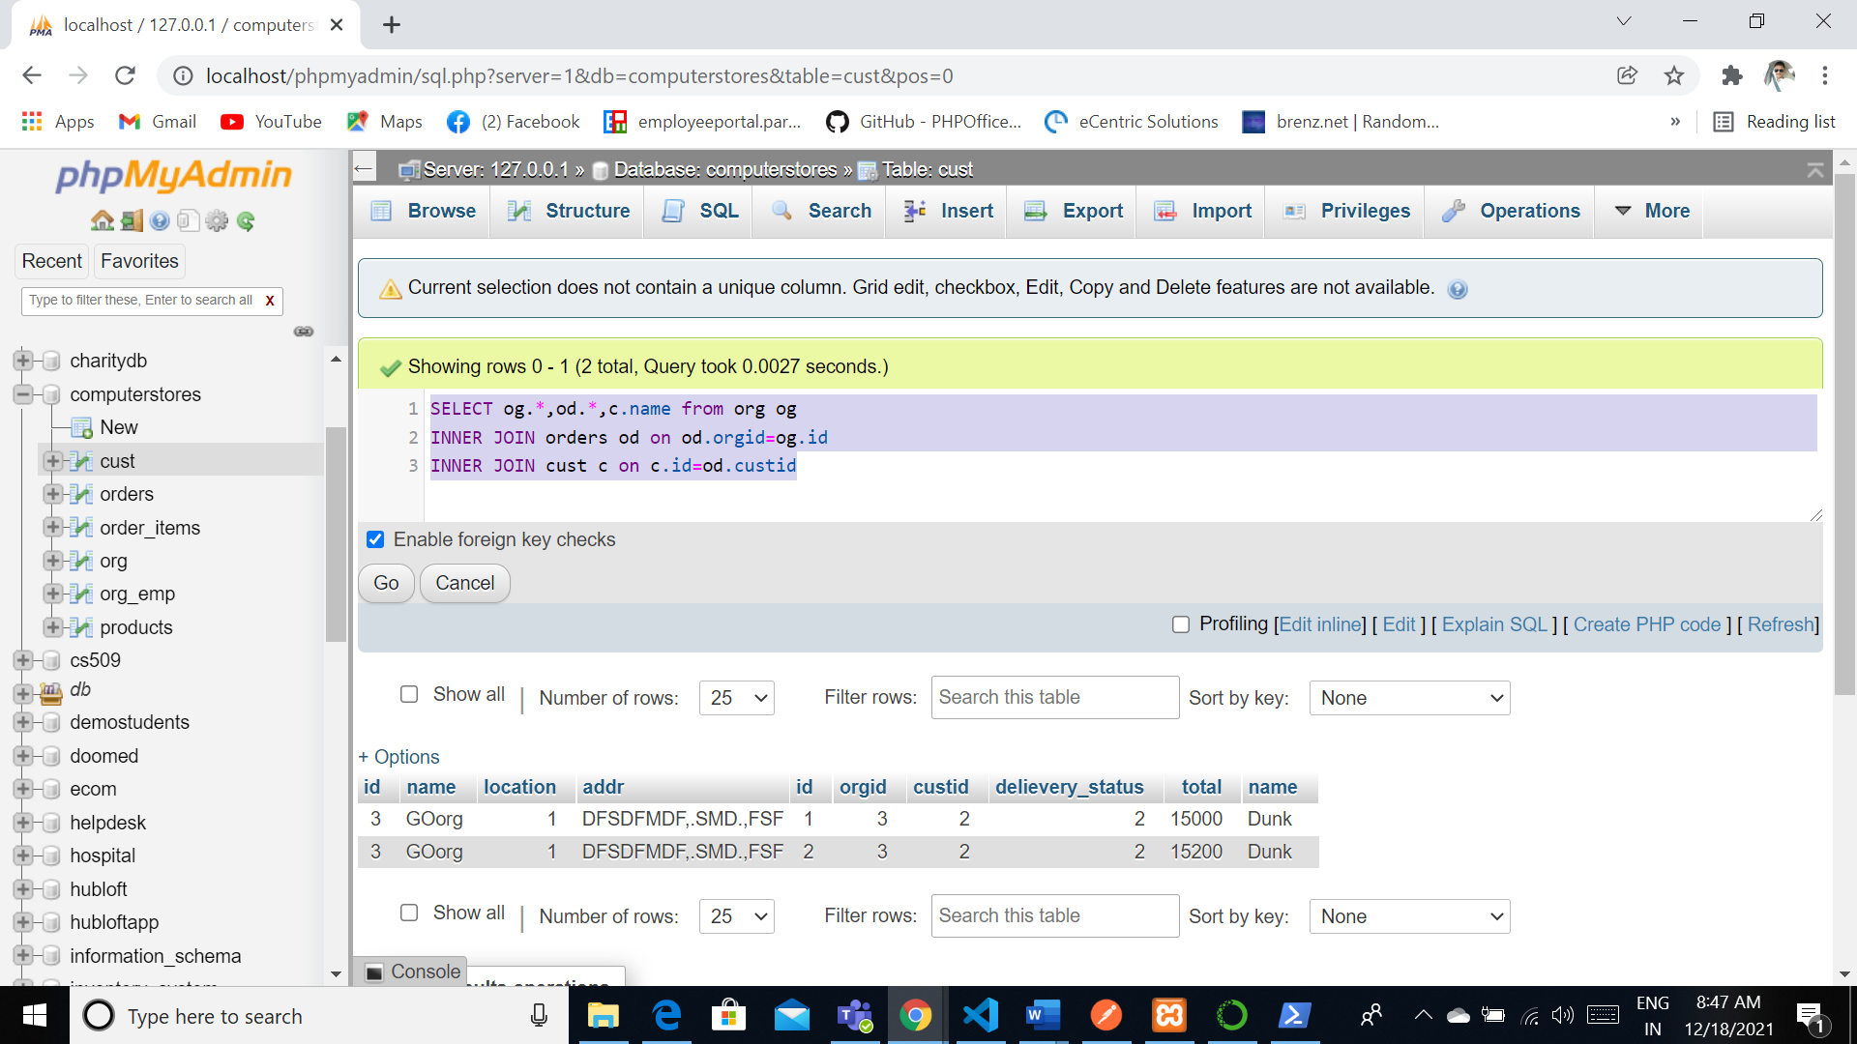

Desc Cust

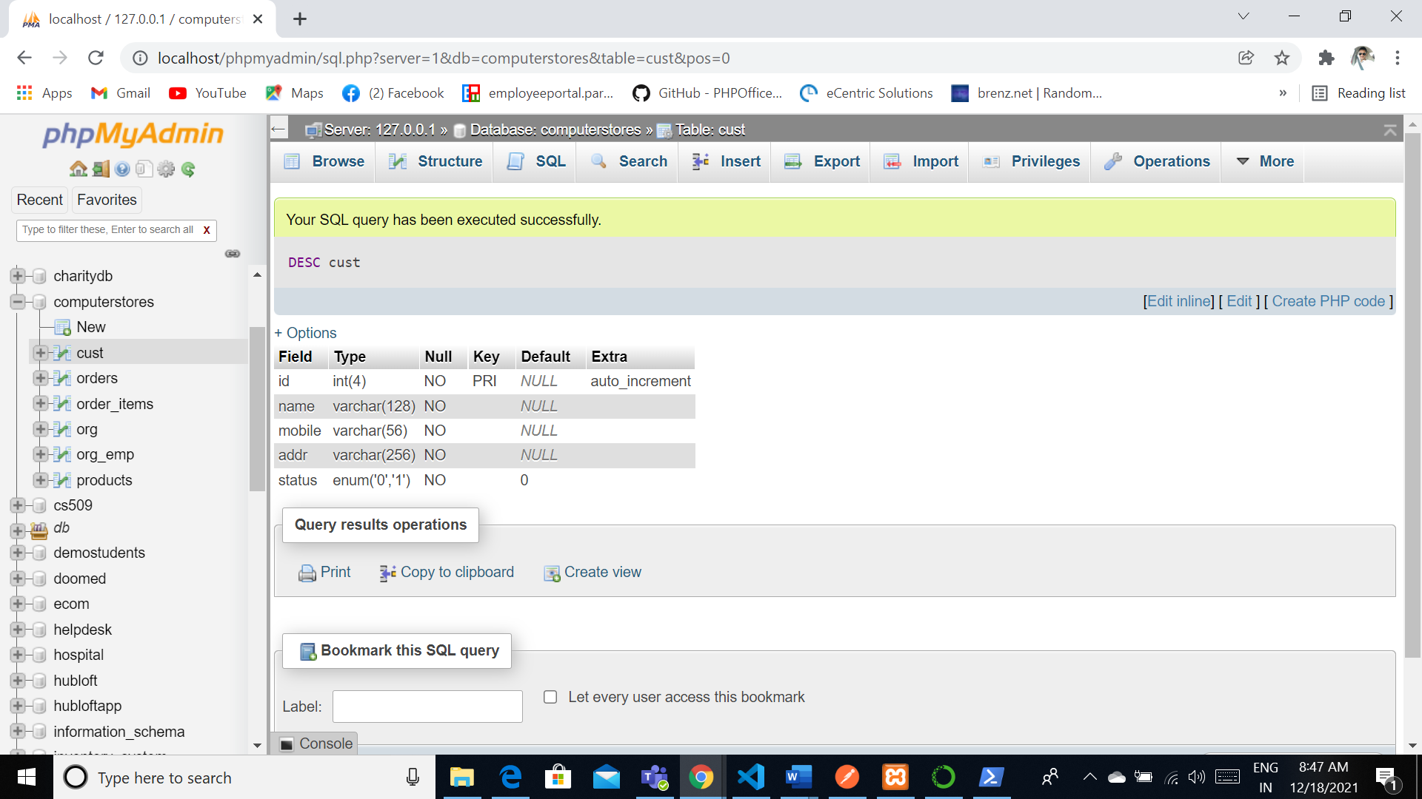

Desc orders



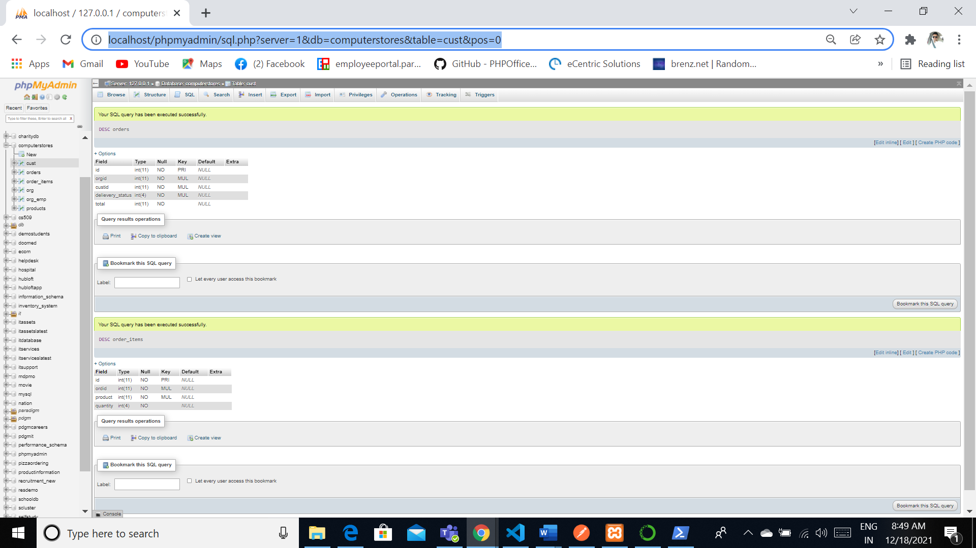

SELECT og.*,od.*,c.name from org og INNER JOIN orders od on od.orgid=og.id INNER JOIN cust c on c.id=od.custid

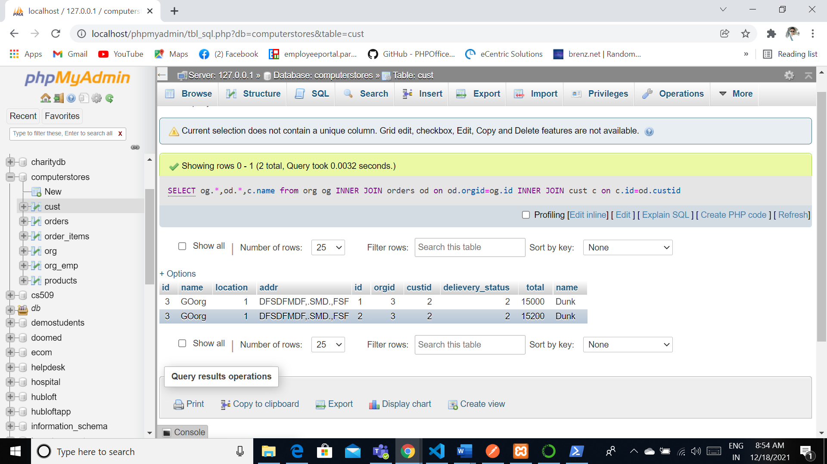

**Indexes**

The Indexes will help the database to be in the less redundant and it could be able to update their information easily. They can be easily referred with other tables where they can be improved in the performance.

CREATE INDEX orgid ON orders (orgid);

CREATE INDEX custid ON orders (custid);

CREATE INDEX delievery_status ON orders (delievery_status);

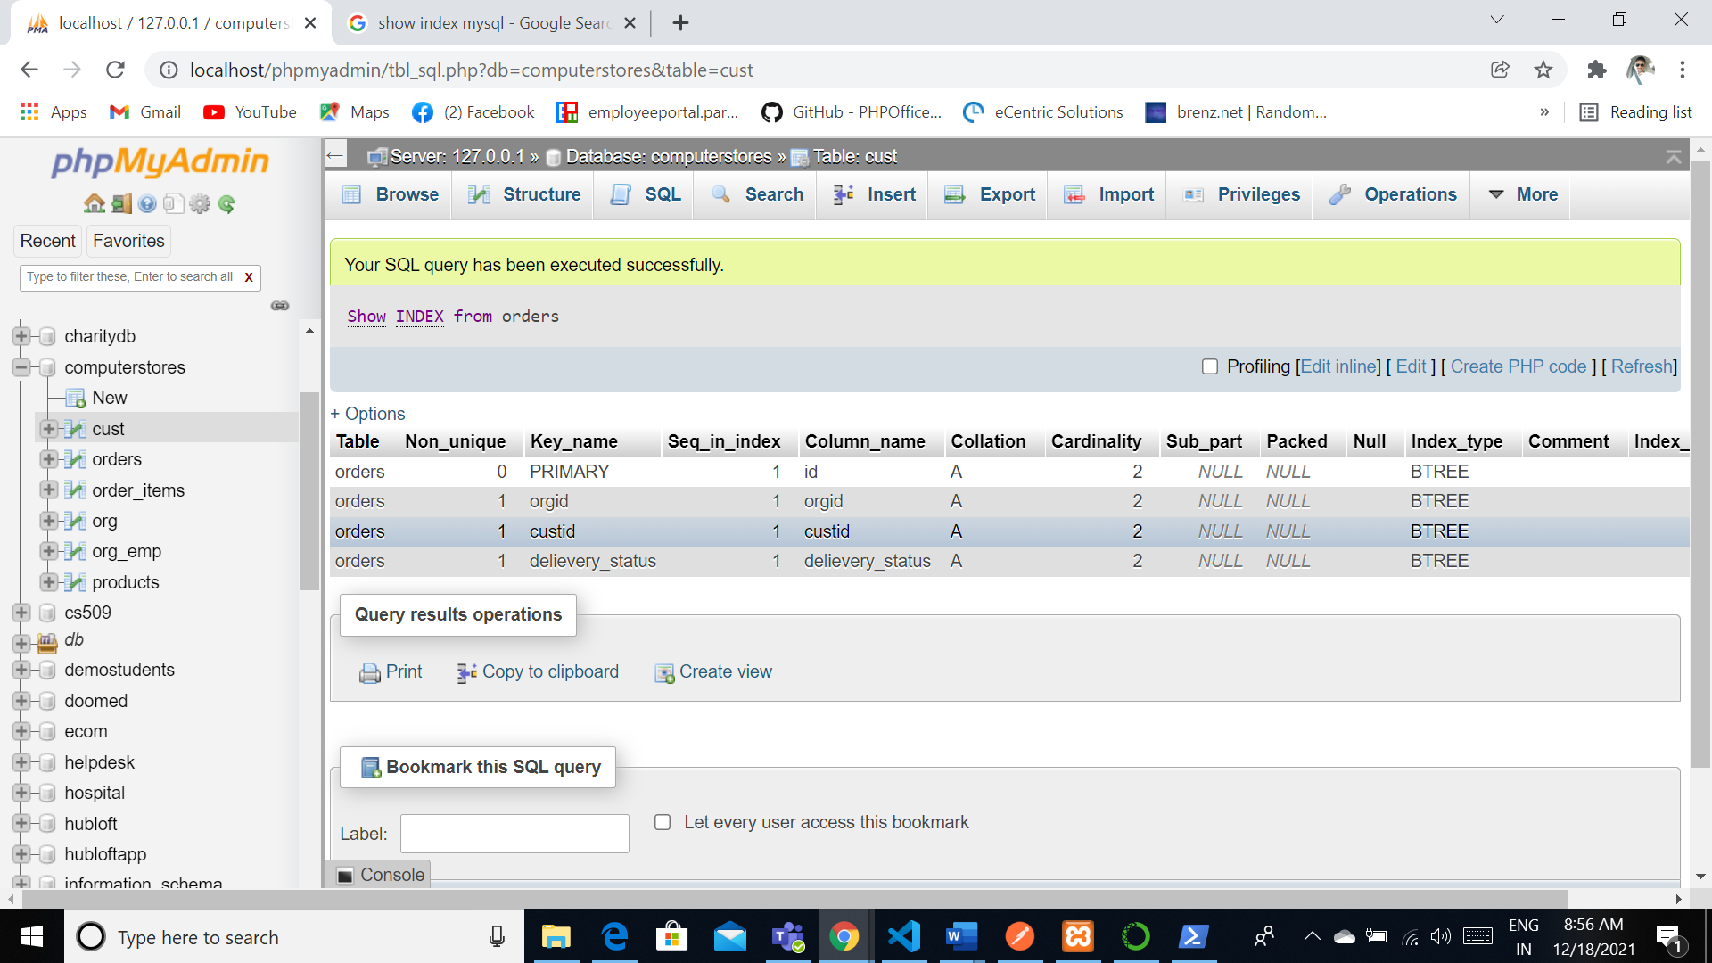

CREATE INDEX ordid ON order_items (ordid);

CREATE INDEX product ON order_items (product);

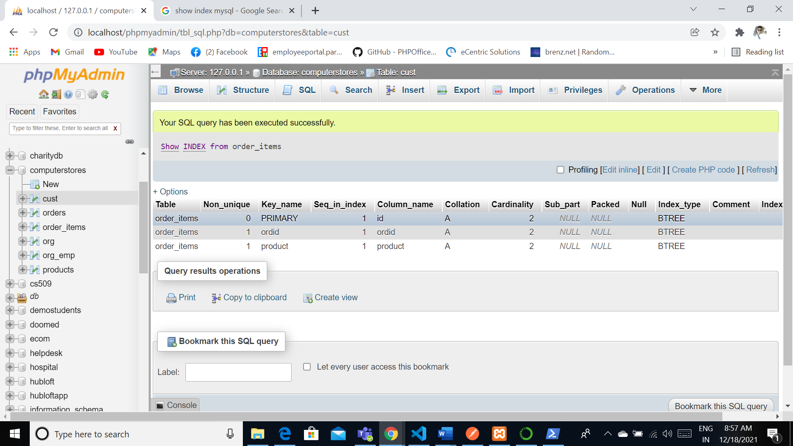

CREATE INDEX id ON org (id);

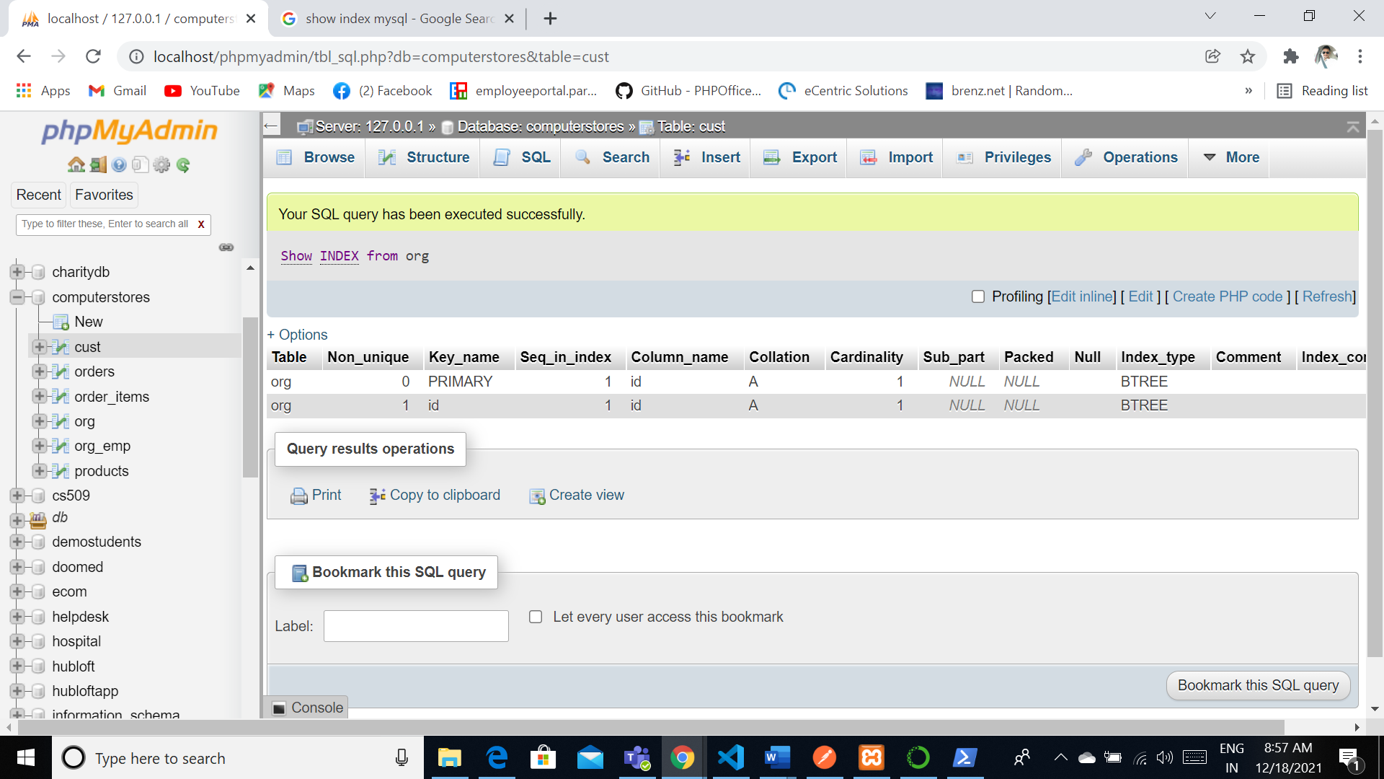

**Views**

These views will always give lot of handy work towards the application so they can be organized that these view are acts as virtual tables based on the requirement. Developers are used to develop the issue.

CREATE VIEW List

AS

SELECT og.name org,od.*,c.name from org og INNER JOIN orders od on od.orgid=og.id INNER JOIN cust c on c.id=od.custid

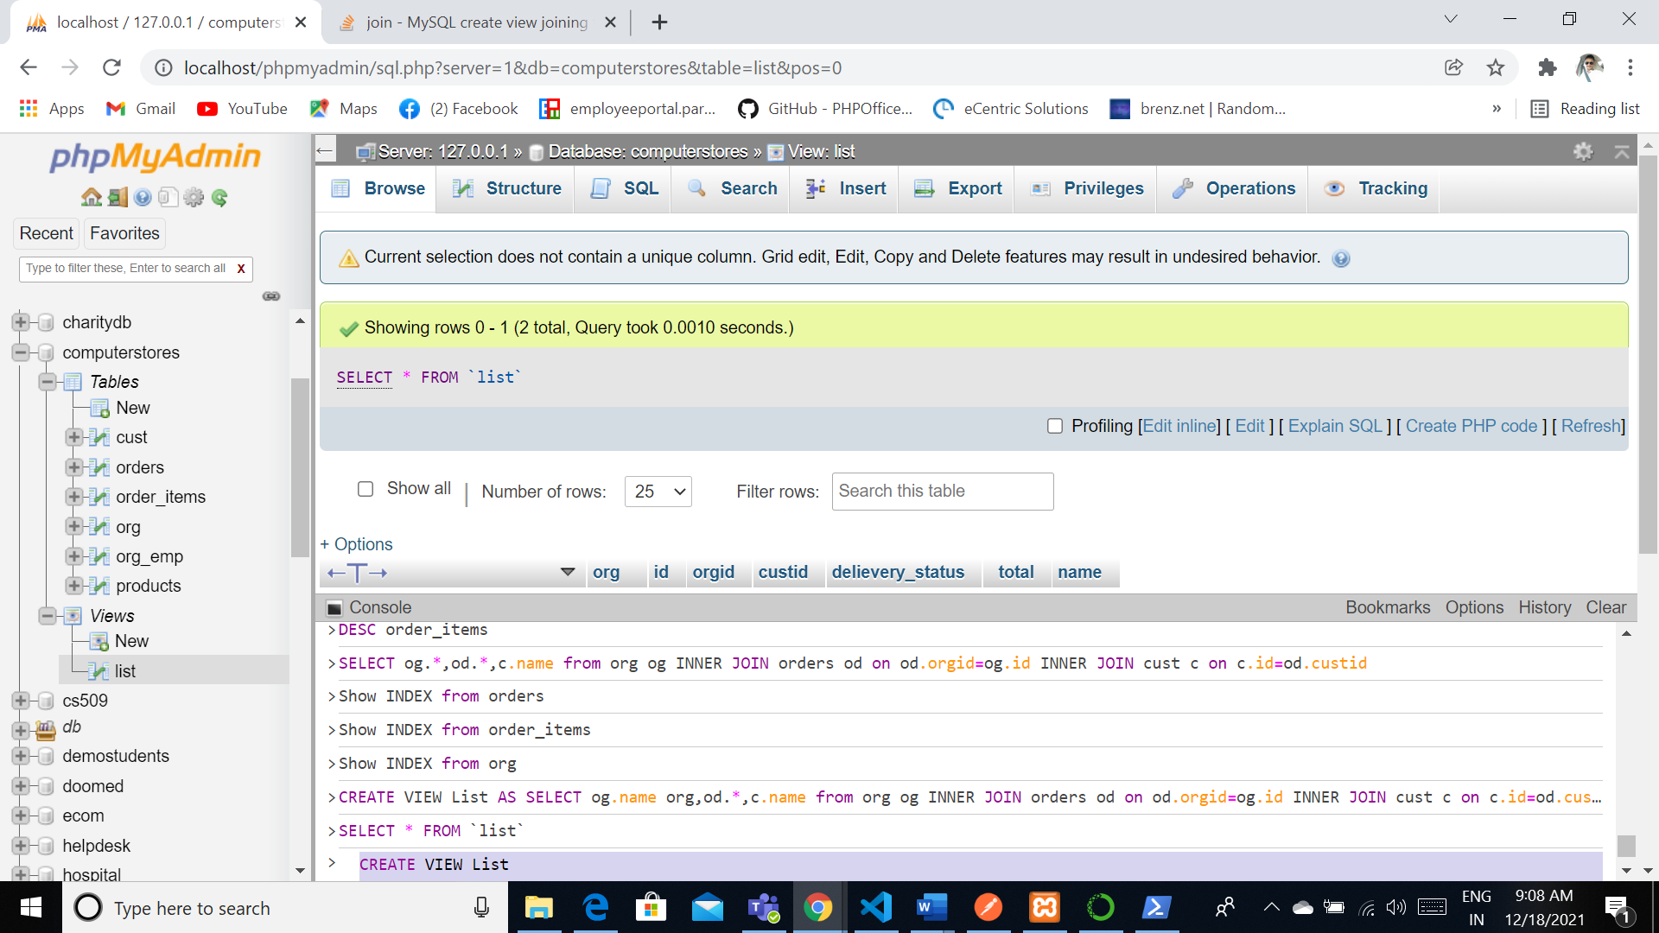

CREATE VIEW orgdata

AS

SELECT oge.name org,og.* from org og INNER JOIN org_emp oge on oge.orgid=og.id

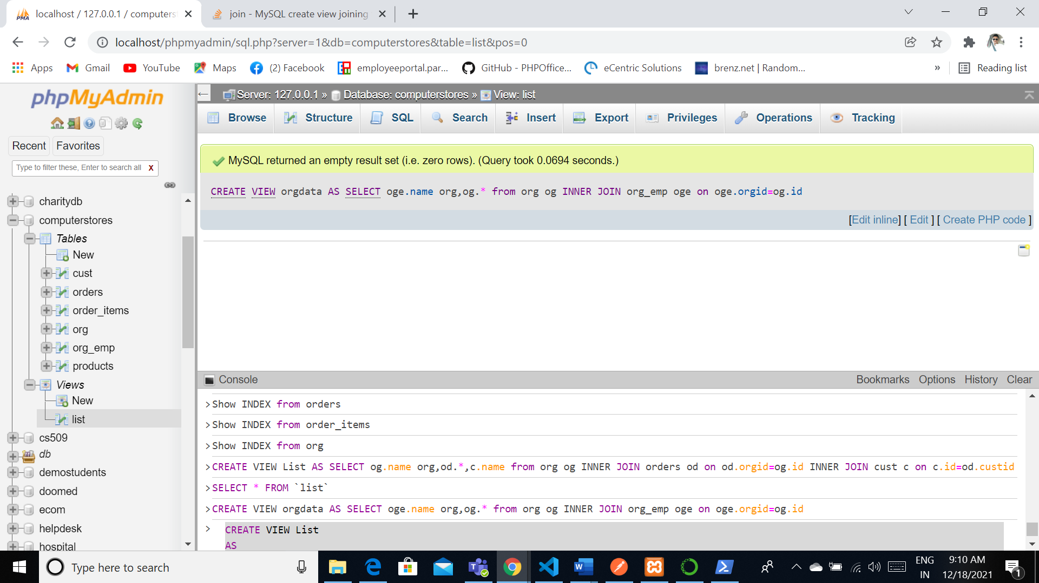

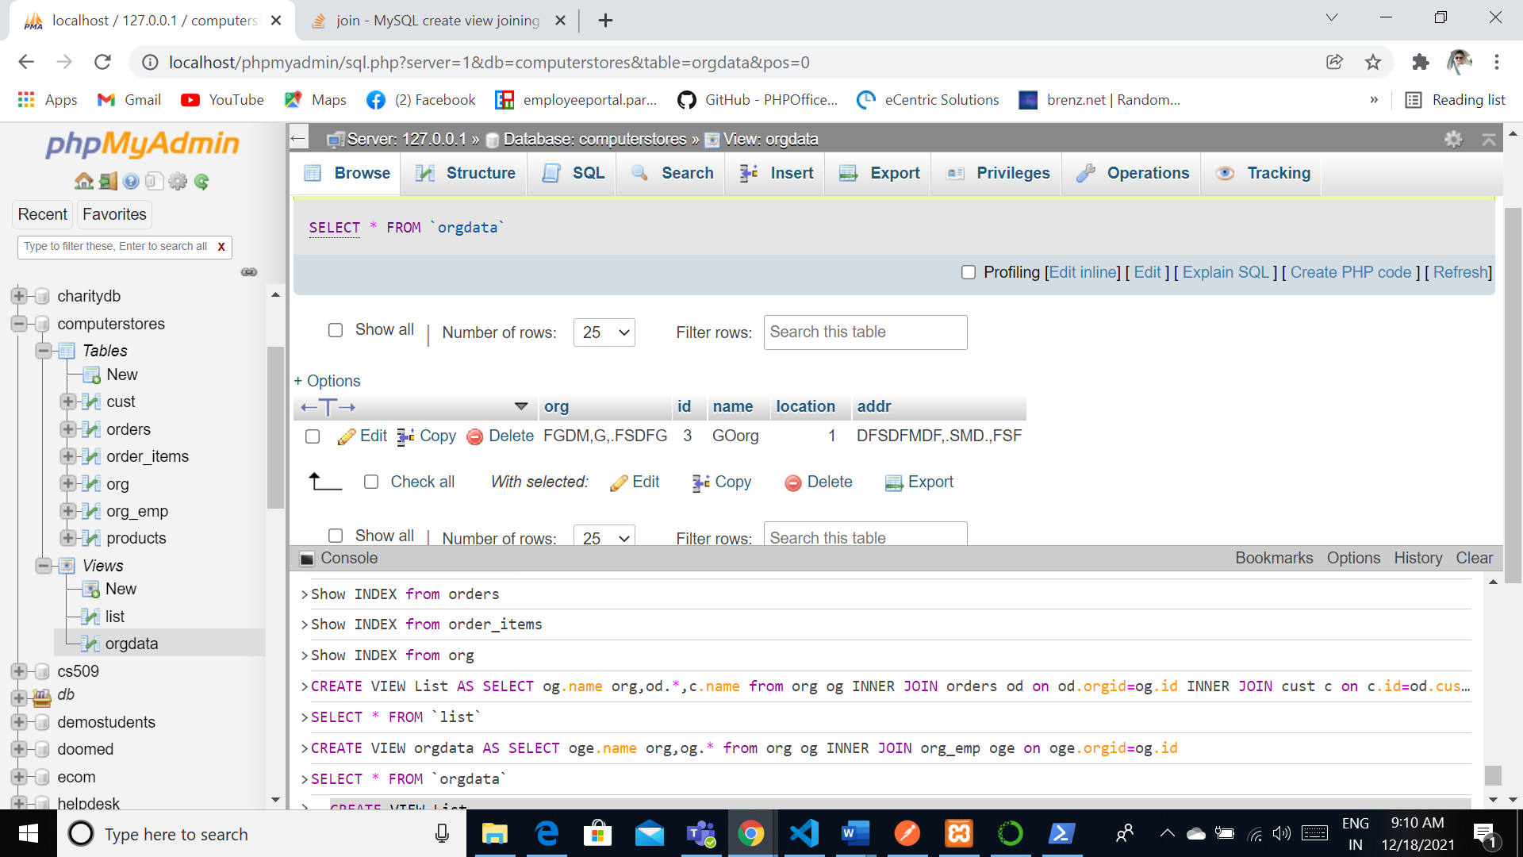

**Triggers**

[CREATE](http://localhost/phpmyadmin/url.php?url=https://dev.mysql.com/doc/refman/5.5/en/create-trigger.html) [TRIGGER](http://localhost/phpmyadmin/url.php?url=https://dev.mysql.com/doc/refman/5.5/en/create-trigger.html) price_sum BEFORE [INSERT](http://localhost/phpmyadmin/url.php?url=https://dev.mysql.com/doc/refman/5.5/en/insert.html) ON products FOR EACH ROW [SET](http://localhost/phpmyadmin/url.php?url=https://dev.mysql.com/doc/refman/5.5/en/set.html) @sum = @sum + NEW.price

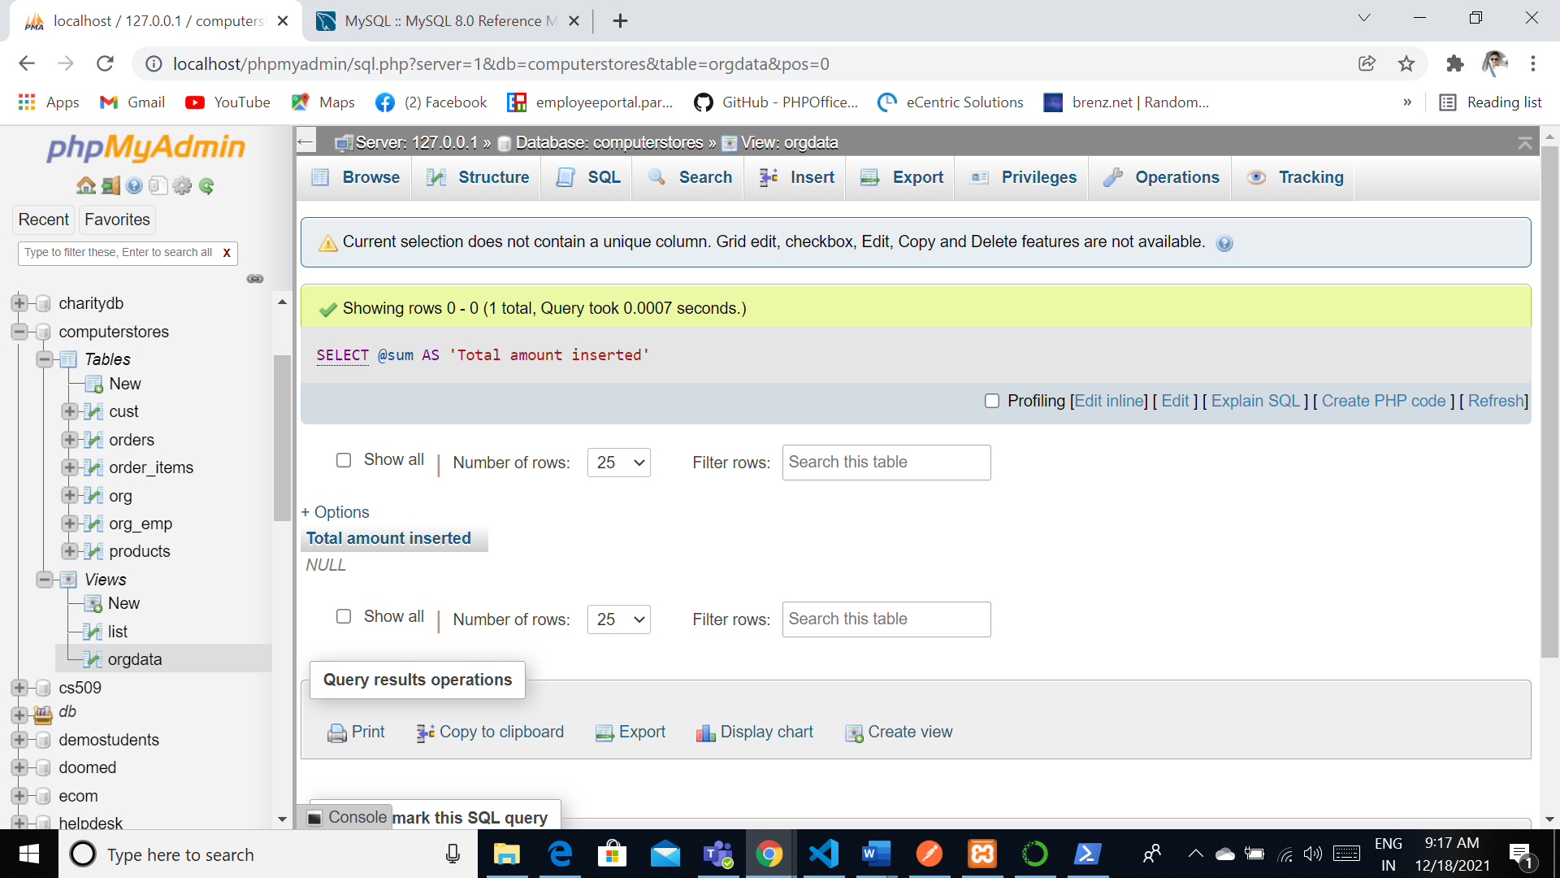

**Transactions**

**START TRANSACTION**

[SELECT](http://localhost/phpmyadmin/url.php?url=https://dev.mysql.com/doc/refman/5.5/en/select.html) @A:=[SUM](http://localhost/phpmyadmin/url.php?url=https://dev.mysql.com/doc/refman/5.5/en/group-by-functions.html#function_sum)(price) FROM products

[UPDATE](http://localhost/phpmyadmin/url.php?url=https://dev.mysql.com/doc/refman/5.5/en/update.html) orders [SET](http://localhost/phpmyadmin/url.php?url=https://dev.mysql.com/doc/refman/5.5/en/set.html) total=@A WHERE orgid=1

COMMIT

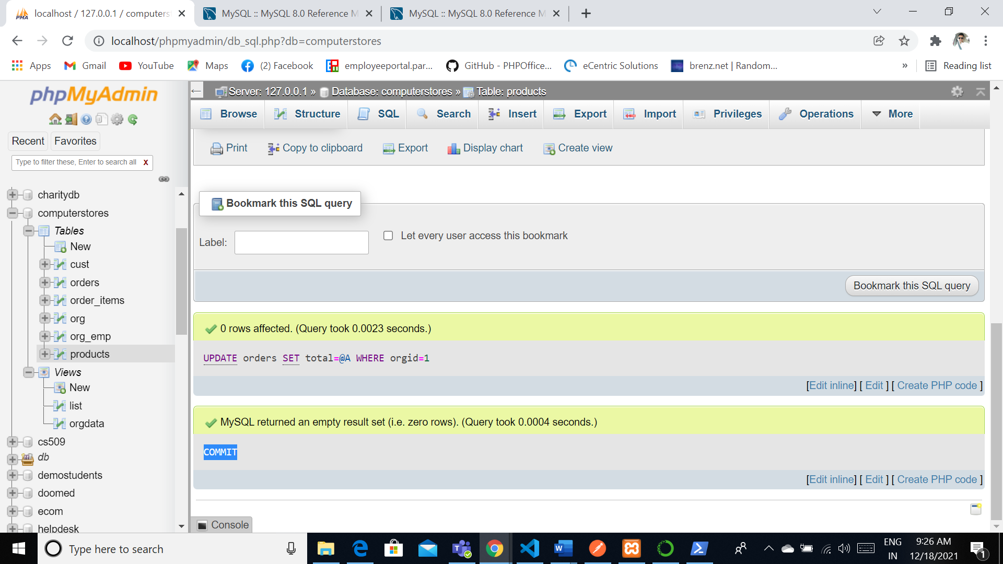

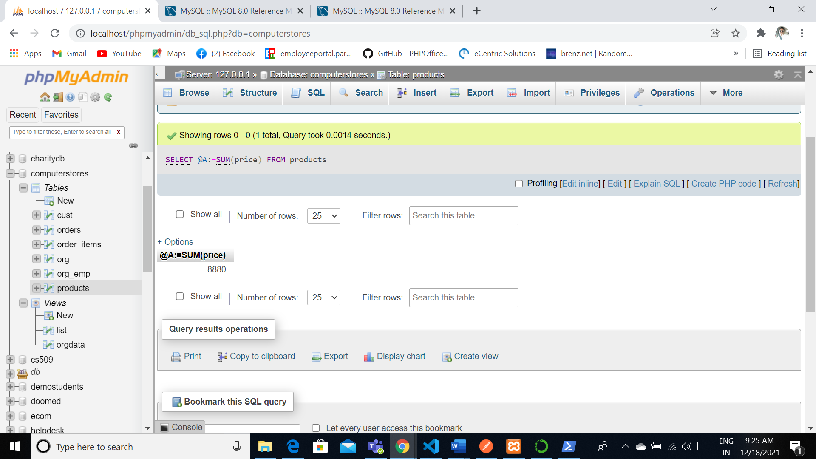

**Security**

In general we will be having the two different types of the user that they could be able to access the databases they are root user and remote users. Generally root users can have the complete permissions and privileges where as the other users will only have the granted permissions. Root users could able to grant the permissions for the other users.

(SELECT DISTINCT `User`, `Host` FROM `mysql`.`user` ) UNION (SELECT DISTINCT `User`, `Host` FROM `mysql`.`db` ) UNION (SELECT DISTINCT `User`, `Host` FROM `mysql`.`tables_priv` ) UNION (SELECT DISTINCT `User`, `Host` FROM `mysql`.`columns_priv` ) UNION (SELECT DISTINCT `User`, `Host` FROM `mysql`.`procs_priv` ) ORDER BY `User` ASC, `Host` ASC

Will give the list of users that were being the part of the each and every database

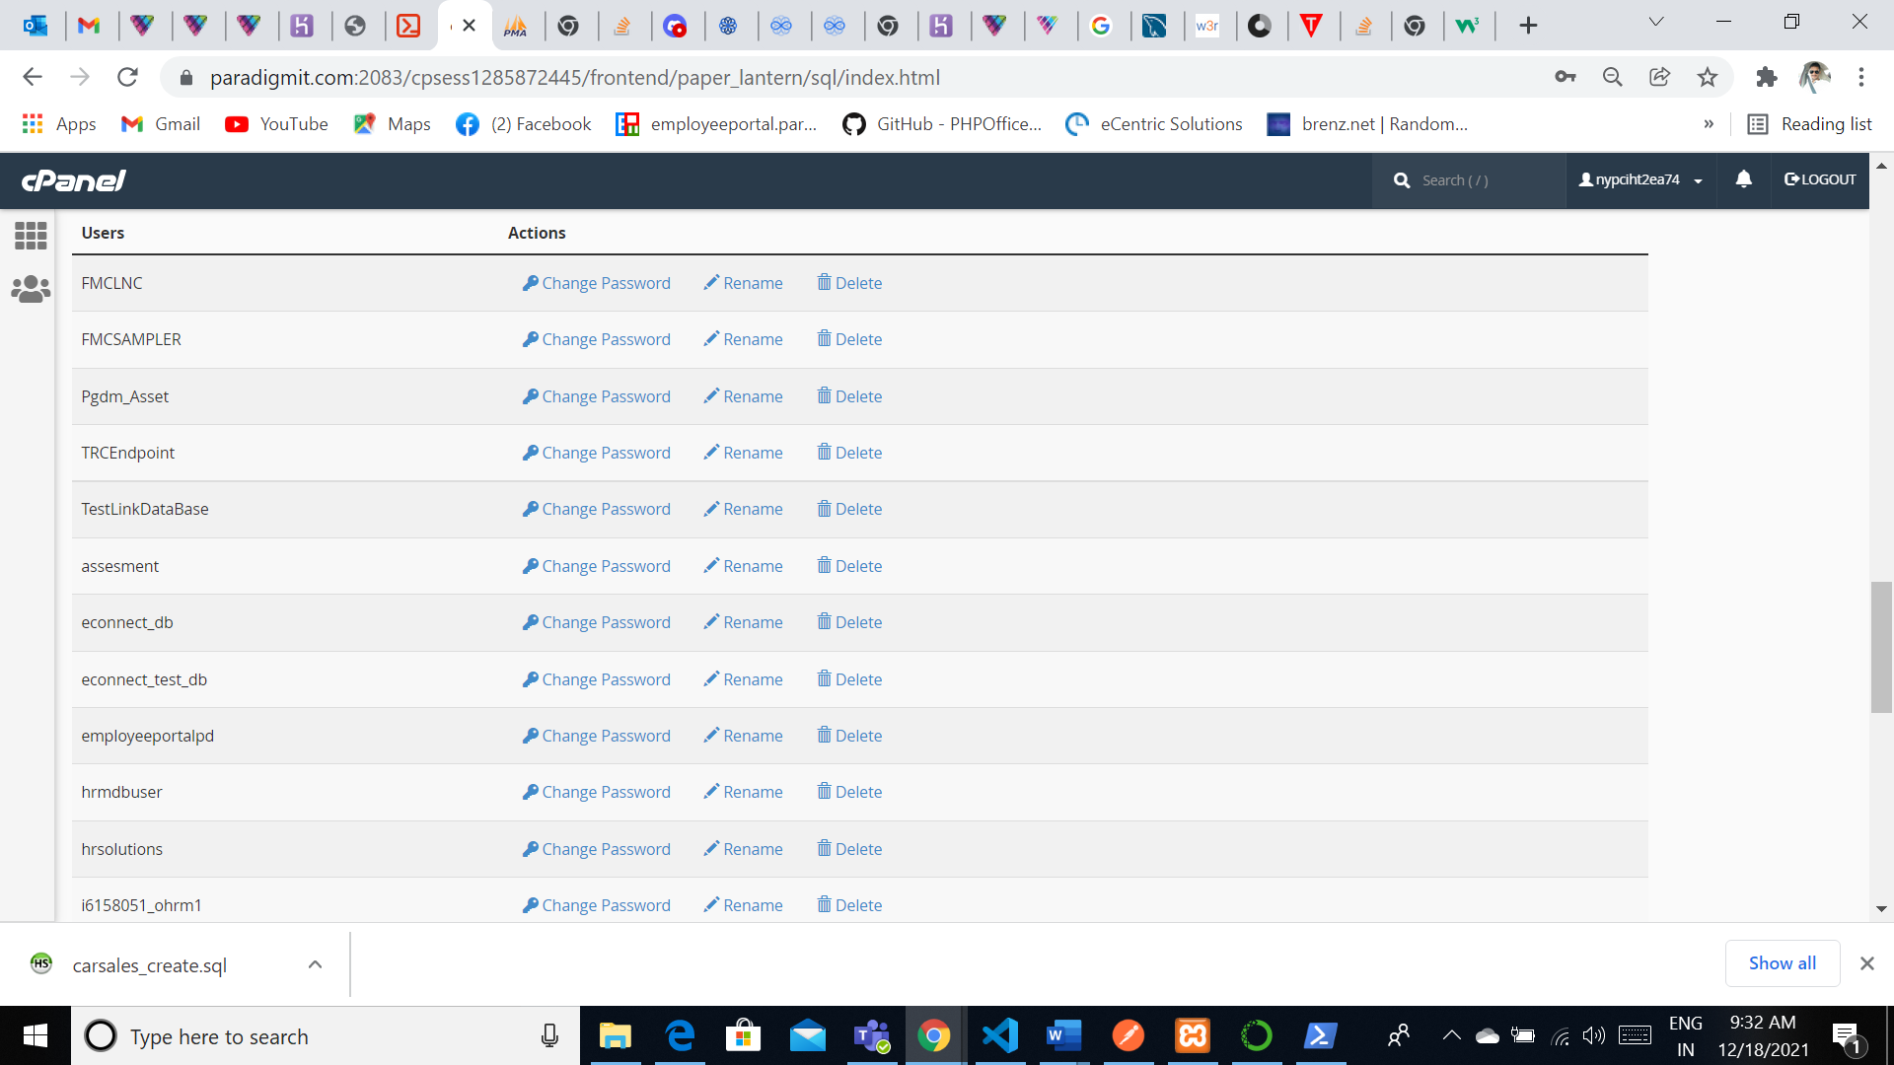

GRANT ALL PRIVILEGES ON [computerstores](http://localhost/phpmyadmin/db_structure.php?server=1&db=computerstores).* TO root@'localhost';

Locking:

[LOCK](http://localhost/phpmyadmin/url.php?url=https://dev.mysql.com/doc/refman/5.5/en/lock-tables.html) [TABLES](http://localhost/phpmyadmin/url.php?url=https://dev.mysql.com/doc/refman/5.5/en/lock-tables.html) products READ

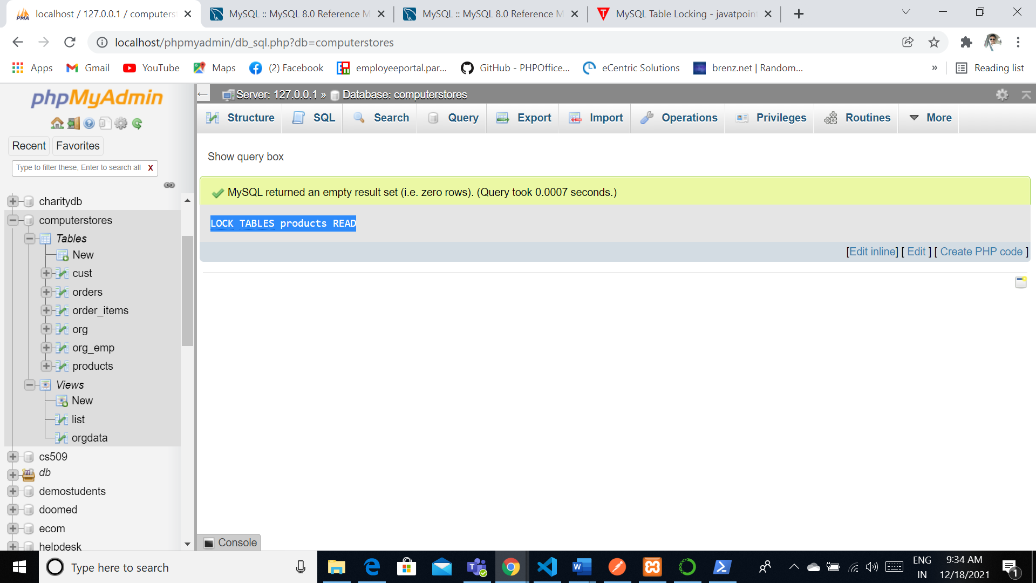

**Backup:**

**For backup we will be using cronjob method for to have the frequent backups of this complete database. So we will not make the script way to download and what to download and how everything will be download based on the export that we have provided for the system. And most of the times this backup will be automated in the Cron jobs and will set up as a place that where the complete solution needs to be backed up in a timely frequency like generally will be automating the script that the complete backup will be stored at a secure place. We will give some restrictions for that folder kind of a restriction for aes265 encryptions.**

set path=c:\wamp\bin\mysql\mysql5.1.36\bin

mysqldump -u root -p computerstores>backuptimestamp.sql

Python:

import datetime

import mysql.connector

cnx = mysql.connector.connect(user='root', database='computerstores')

cursor = cnx.cursor()

query = ("select * from list")

hire_start = datetime.date(1999, 1, 1)

hire_end = datetime.date(1999, 12, 31)

cursor.execute(query)

for (name) in cursor:

print(name)

cursor.close()

cnx.close()

Output:

('GOorg', 1, 3, 2, 2, 15000, 'Dunk')

('GOorg', 2, 3, 2, 2, 15200, 'Dunk')

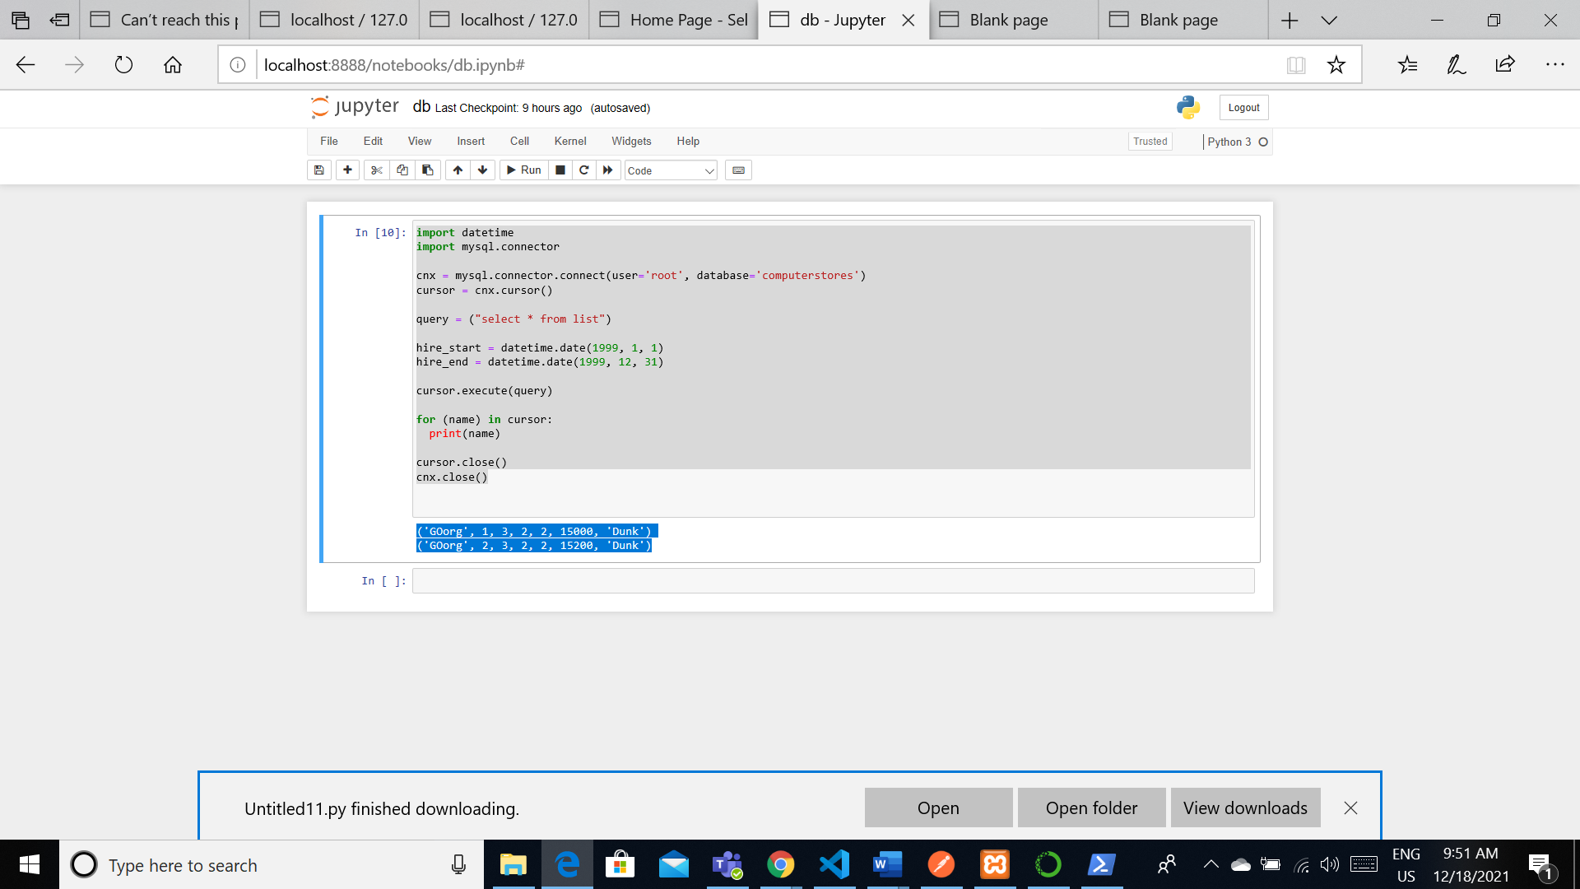

**PHP Application**

**Basic html for search**

<!DOCTYPE html>

<html>

  <body>

    <!-- (A) SEARCH FORM -->

    <form method="post" action="index.php">

      <h1>SEARCH FOR PRODUCTS</h1>

      <input type="text" name="search" required/>

      <input type="submit" value="Search"/>

    </form>

    <?php

    // (B) PROCESS SEARCH WHEN FORM SUBMITTED

    if (isset($_POST["search"])) {

      // (B1) SEARCH FOR USERS

      require "search.php";

      // (B2) DISPLAY RESULTS

      if (count($results) > 0) { foreach ($results as $r) {

        printf("<div>%s - %s</div>", $r["name"], $r["specifications"]);

      }} else { echo "No results found"; }

    }

    ?>

  </body>

</html>

PHP code for search the database:

<?php

// (A) DATABASE CONFIG - CHANGE TO YOUR OWN!

define("DB_HOST", "localhost");

define("DB_NAME", "computerstores");

define("DB_CHARSET", "utf8");

define("DB_USER", "root");

define("DB_PASSWORD", "");

// (B) CONNECT TO DATABASE

try {

  $pdo = new PDO(

    "mysql:host=".DB_HOST.";charset=".DB_CHARSET.";dbname=".DB_NAME,

    DB_USER, DB_PASSWORD, [

      PDO::ATTR_ERRMODE => PDO::ERRMODE_EXCEPTION,

      PDO::ATTR_DEFAULT_FETCH_MODE => PDO::FETCH_ASSOC

    ]

  );

} catch (Exception $ex) { exit($ex->getMessage()); }

// (C) SEARCH

$stmt = $pdo->prepare("SELECT * FROM `products` WHERE `name` LIKE ? OR `specifications` LIKE ?");

$stmt->execute(["%".$_POST["search"]."%", "%".$_POST["search"]."%"]);

$results = $stmt->fetchAll();

if (isset($_POST["ajax"])) { echo json_encode($results); }

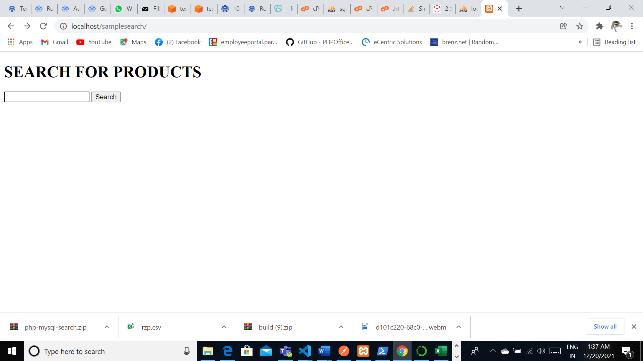

Results:

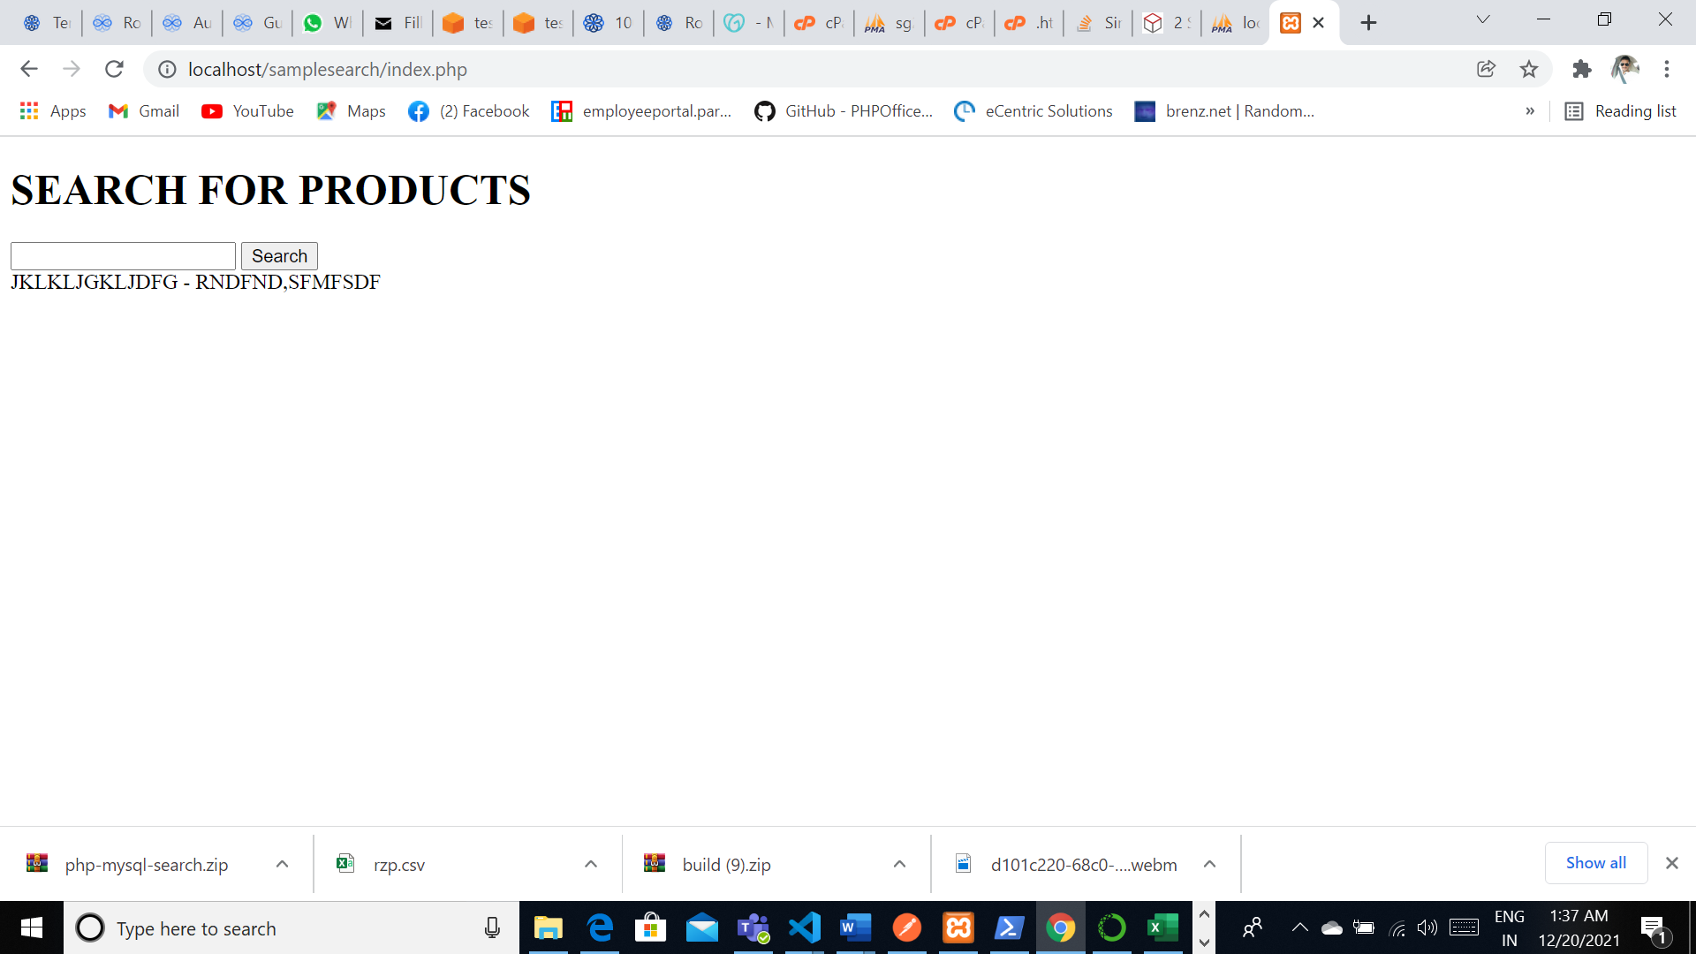

SQL Injections can be handled by using the CRPF token system where we will pass the CSRF token with the data that we will be providing through the data so we can be handled with simple and secure way to handle the system and the information that will be provided over the information.